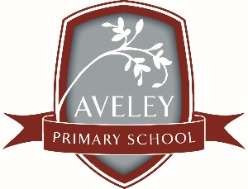
Aveley Primary School-Principal’s Report
P&C February 2026 (AGM)

Welcome back to Term One. We have had a very busy start to the year. This year staff enthusiastically returned to school and participated in a variety of Professional Learning, which included some strategic planning for 2026, mental health and wellbeing and setting up the year ahead for success.

Welcome back event-Thank you for running the Welcome Back event at the end of Week One. It was nice to spend some time with families during the afternoon. Next year I will promote and encourage more staff participation at the event. It really resonated with my mantra for the year of Connection before Content.

Parking update- families have continued to respect the no drop off and pick up in the staff carpark on Edgerton Dr, COS Parking Wardens will be doing some education visits and follow up with people who continue to park in spaces that are not designated.

We have our Public School Review report, there were lots of positive commendations along with recommendations for future directions. Thanks to Peta for being part of the panel for the Relationships and Partnerships domain in Nov 2025.

We have a busy term ahead with Year Six camp in week 6, NAPLAN testing for Year Three’s and Five’s and our School Development Day with Merrilee Wright (from Real Schools) as we enter the second year of our 3-year partnership. Please note this term is 9 weeks long.

At the next P&C meeting I will present from the Finance Committee the P&C Wish List for the 2026 year.

Looking forward to another great year together.

Natalie Bracegirdle
Principal
16/02/2026

